**Solihull Parenting Team** 👪





**Parenting Challenges in Lockdown**

Parenting can be challenging, even more so during lockdown. You may have tried some of the following ideas, but if not they are worth trying. Please get in touch if you would like more help or support [bsmhft.parenting@nhs.net](mailto:bsmhft.parenting@nhs.net)

**I have to do everything in this house!**

Parental involvement is a great thing. But taking over and doing too much for our children isn’t good for them. In order to develop good self-esteem and life skills, children need to do things for themselves, to make mistakes and to learn from their failures. Running around picking up after children who are old enough to do things for themselves is not an act of love, it’s an act of developmental sabotage. Plus you will become exhausted.

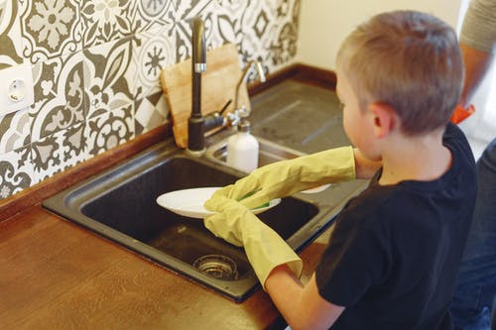



**The children are always fighting!**

Avoid constant firefighting by setting some clear, simple and positive ground rules/household rules. The best rules help children focus on what good behaviour looks like so they can do it more often. If unpleasant comments are the issue, then ‘use kind words’ might be a good rule. Or, if physical aggression is the problem, ‘be gentle’. Use praise, attention & rewards systems to positively reinforce the behaviour you want to encourage.

**I’m still working, so don’t have enough time for the children!**

Working parents are often flooded with guilt about not being able to give their children enough attention. But it’s not how much attention we give that’s the crucial issue, it’s where we direct it. Creating a happy family home isn’t about finding extra hours, it’s about parenting smarter by targeting your attention towards the behaviour you want to encourage. Plan your family’s day, children thrive on routine, allow time to work, eat & have fun together. Your attention means everything to your children, and they’ll do pretty much anything to get it.



