**Solihull Parenting Team** 👪





**Parenting Challenges in Lockdown**

Parenting can be challenging, even more so during lockdown. You may have tried some of the following ideas, but if not they are worth trying. Please get in touch if you would like more help or support [bsmhft.parenting@nhs.net](mailto:bsmhft.parenting@nhs.net)



**How do I priorities 1:1 time for the children?**

We tend to focus on all those tasks that need completing during family time. Feeding, washing, school work, however families are made up of relationships, not tasks. Building a relationship isn’t a job, it’s about small choices we make day-to-day. It’s about chatting, laughing or slowing down for a few minutes to listen when our child has something to say – reflective listening, using all our attention. Through listening we connect with our children on a deeper level and get to know them. Building relationships isn’t about quantities of time, it’s about quality moments.

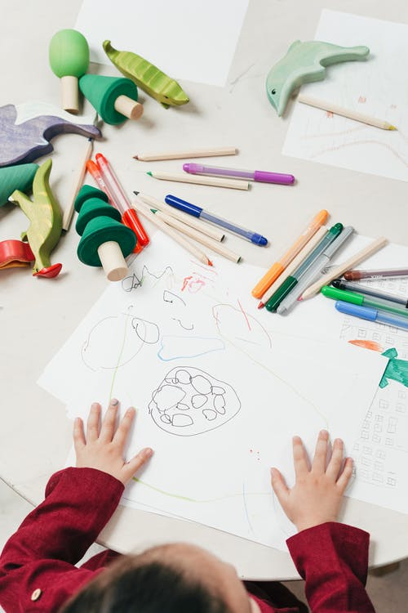

**The children just want to play!**

Play is an essential ingredient for happy families. Children and adults need it. If you take the play out of parenting, all you’re left with is tasks. Play makes our lives feel lighter. It improves children’s social, emotional and brain development, makes parenting enjoyable, strengthens family bonds and boosts everyone’s wellbeing. Creating more space for play will give you room to breathe, to relax, to laugh more, shout less and enjoy being a happy member of your family.

